**NPI000150 INDIVISUAL PART**

**Individual part: DDL**

Screen shot and table are given below of query and their respective result.

**Database**

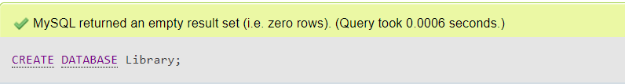

Fig 1: Query to create database

**Book**

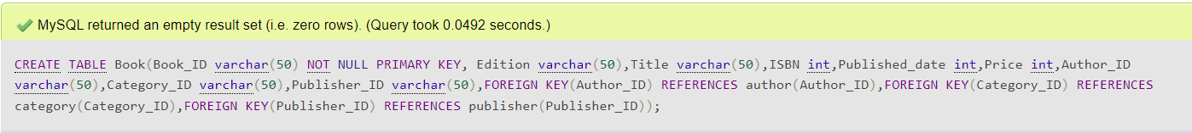

Fig 2: Query to create table

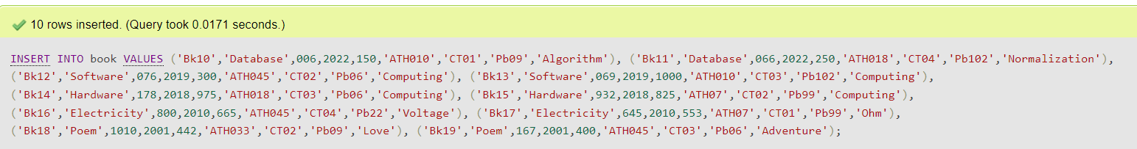

Fig 3: Query to insert value in book table

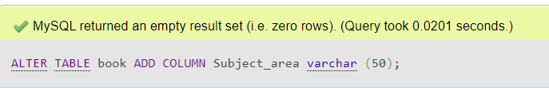

Fig 4: Adding column in book

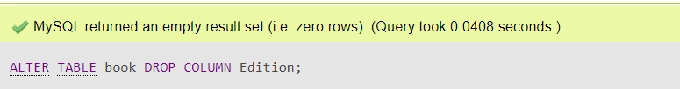

Fig 5: Drop column in book

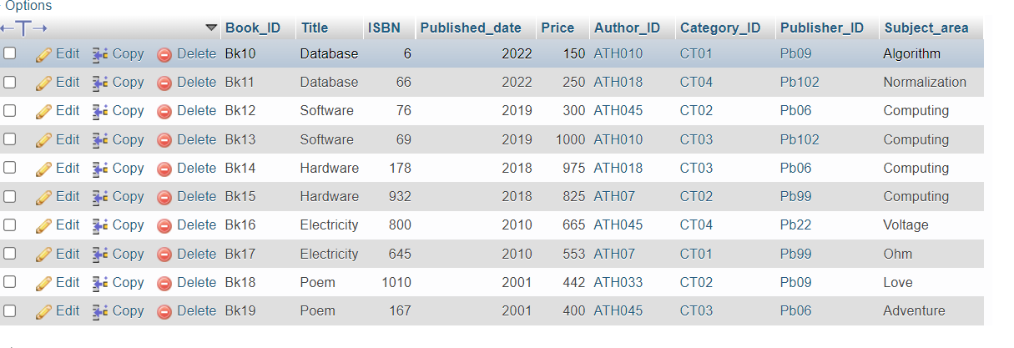

Fig 6: Overall table of book

**Author**



Fig 7: Query to create author table



Fig 8: Query to insert value

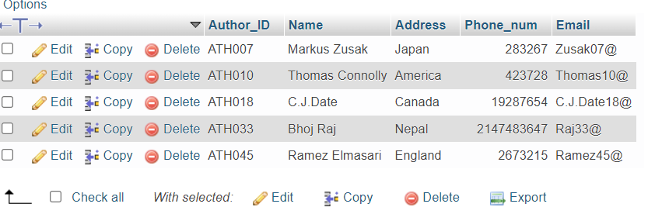

Fig 9: Overall table of Author

**Bill**



Fig 10: Query to create bill table

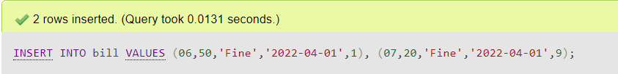

Fig 11: Query to insert value in table

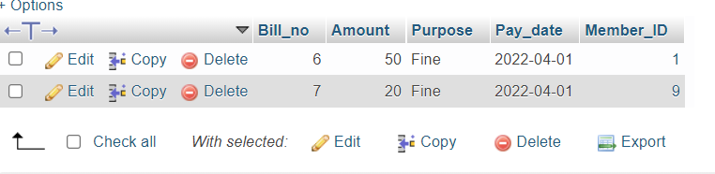

Fig 12: Overall table of bill

**Book_loan**



Fig 13: Query to create book_loan table

Fig 14: Query to insert value in table

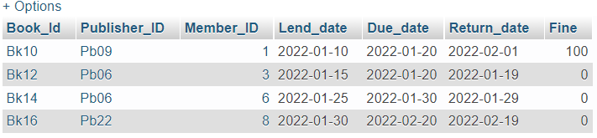

Fig 15: Overall table of Book_loan

**Category**

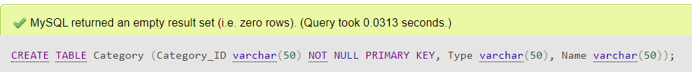Fig 16: Query to create Category table

****Fig 17: Query to insert value in table

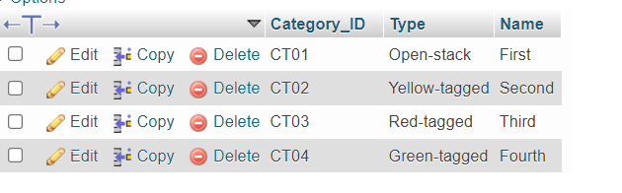

Fig 18: Overall table

**Department**

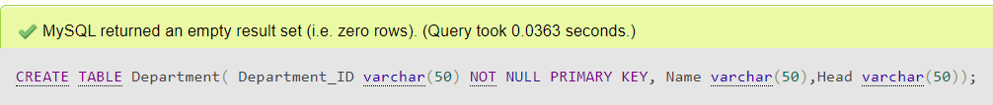Fig 19: query to create department table

****Fig 20: Query to insert values in table

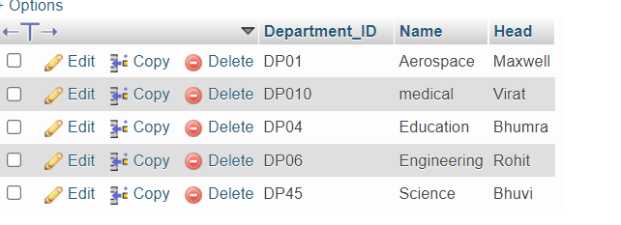

Fig 21: Overall table

**Member**



Fig 22: Query to create member table

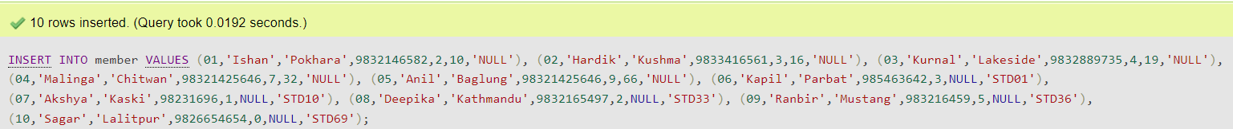

Fig 23: Query to insert values in table

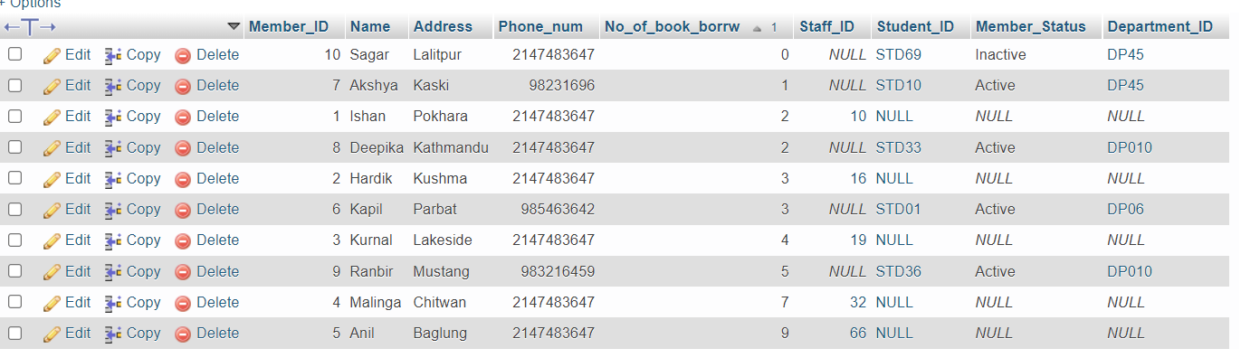

Fig 24: Overall table

In this table member status and Department_ID are added to connect the member table and department table directly.

Query to ADD those column in that table are:

Alter table member add column Member_status varchar (50);

Alter table member add column Department_ID varchar (50);

**Publisher**



Fig 25: Query to create publisher table



Fig 26: Query to insert values in table

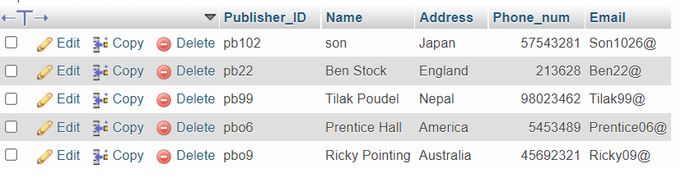

Fig 27: Overall table

**Report**



Fig 28: Query to create report table



Fig 29: Query to insert values in table

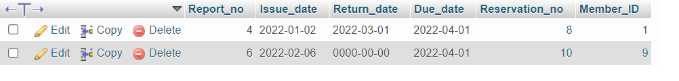

Fig 30: Overall table

**Reservation**



Fig 31: Query to create reservation table

 Fig 32: Query to insert values in table

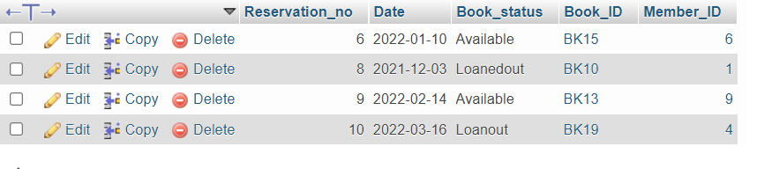Fig 33: Overall table

**Staff**

****Fig 34: Query to create staff table



Fig 35: Query to insert values in table

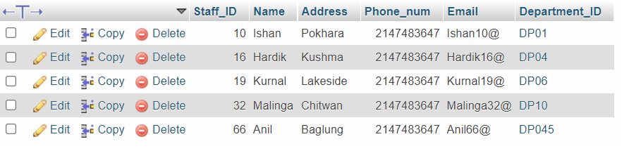

Fig 36: Overall table

**Student**

****Fig 37: Query to create student table

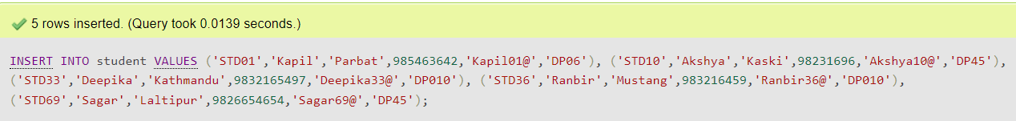Fig 38: Query to insert values in table

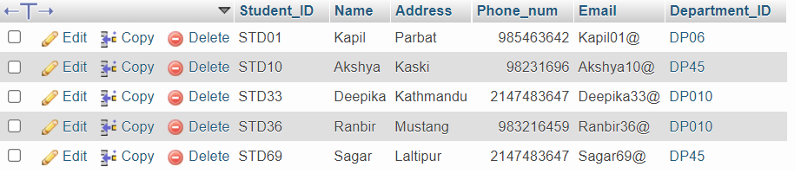

Fig 39: Overall table

**DML**

Sql data manipulation language:

From the question number 2.

**Question number 2 a) Answer**

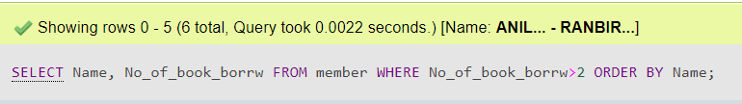

Fig 40: Query

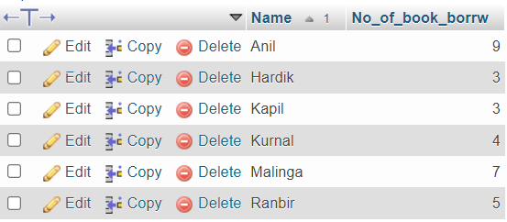

Fig 41: Result

**Question number 2 b) Answer**

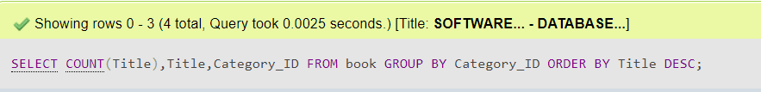

Fig : Query

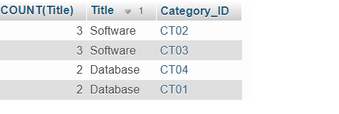

Fig 42: Result

**Question number 2 c) Answer**

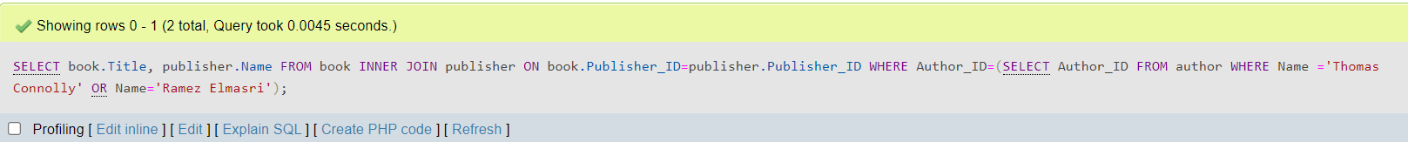

Fig 43: Query

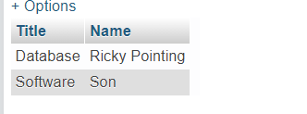

Fig 44: Result

**Question number 2 d) Answer**

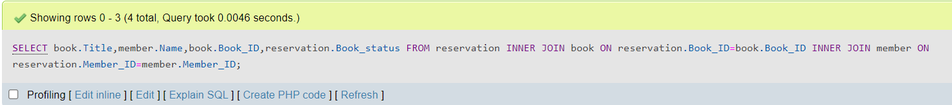

Fig 45: Query

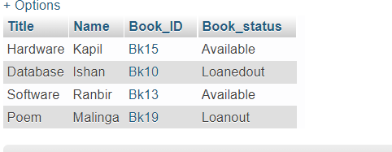

Fig 46: Result

**Question number 2 e) Answer**



Fig 47: Query

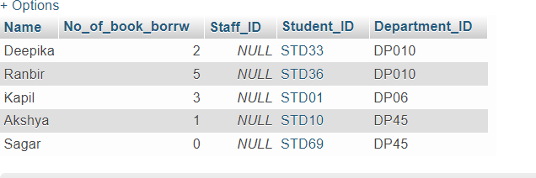

Fig 48: Result

**Question number 2 f) Answer**

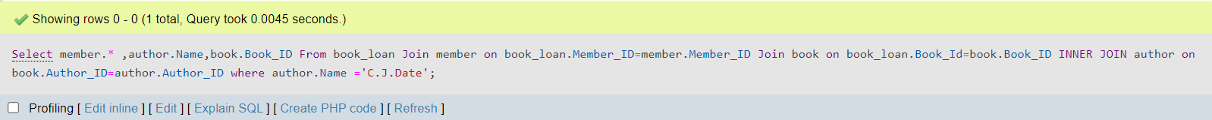

Fig 49: Query



Fig 50: Result

**Question number 2 g) Answer**



Fig 51: Query

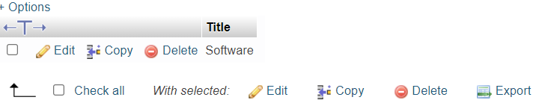

Fig 52: Result

**Question number 2 h) Answer**



Fig 53: Query

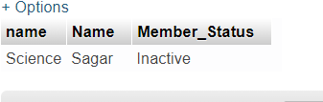

Fig 54: Result

**Question number 2 i) Answer**



Fig 55: Query

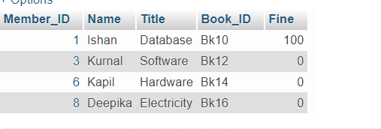

Fig 56: Result

**Question number 2 j) Answer**

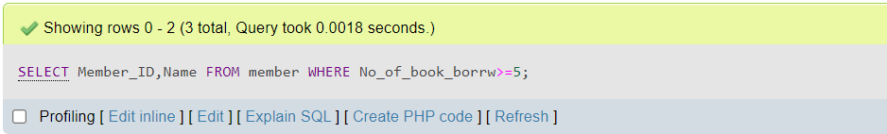

Fig 57: Query

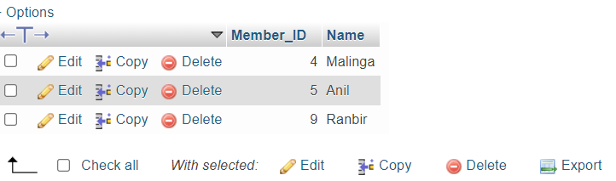

Fig 58: Result

**Question number 2 k) Answer**

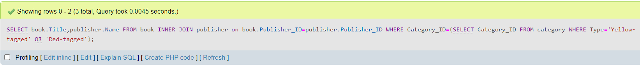

Fig 59: Query

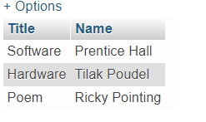

Fig 60: Result

**Question number 2 l) Answer**



Fig 61: Query

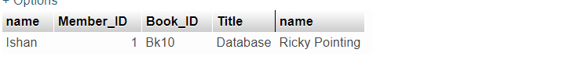

Fig 62: Result